Rascal Interface Control Document

Saint Louis University

Rascal



Last Updated: 4/27/14

Document No: RCL-I-CMQA1

|  |  |  |  |
| --- | --- | --- | --- |
| Prepared by: |  |  |  |
|  | Tom Moline  Rascal Program Manager |  | Date |
| Approval: |  |  |  |
|  | Dr. Michael Swartwout  Argus Principal Investigator |  | Date |

**Revisions Summary**

|  |  |  |  |  |
| --- | --- | --- | --- | --- |
| Revision | Description | Date | Prepared by | Approved by |
| - | Initial Release | 5/2/2014 | Tom Moline | Nate Richard |
|  |  |  |  |  |
|  |  |  |  |  |
|  |  |  |  |  |
|  |  |  |  |  |
|  |  |  |  |  |

Table of Contents

1. Interface Overview 4

2. Primary-Secondary Spacecraft Interfaces 5

2.1. Primary-Secondary Separation Mechanism 5

2.2. Secondary Spacecraft Power Inhibit 6

3. Primary-Colony-II Bus Interfaces 7

4. Ground-Spacecraft Interfaces 9

4.1. Ground-Primary Spacecraft Uplink 9

4.2. Primary Spacecraft-Ground Downlink 9

4.3. Ground-Secondary Spacecraft Uplink 9

# Interface Overview

This Interface Control Document (ICD) serves to define all relevant interfaces between the Space Systems Research Lab’s (SSRL) Rascal payload (consisting of a 3U secondary spacecraft and 1.5U propulsion/image processing unit) and Boeing’s Colony-II bus. These interfaces consist of three major types:

1. **Mechanical -** structural interfaces that involve the physical connections between SSRL-Boeing components.
2. **Electrical –** digital/analog interfaces that involve data communication and power transmission to and from SSRL-Boeing components.
3. **Radio –** RF interfaces that involve data transmission between the ground and either the secondary or primary spacecraft.

Beyond these three designations, each interface can be broken down into three general categories: those that interface the secondary spacecraft with the primary spacecraft, those that interface the image processing/propulsion unit with the rest of the primary spacecraft, and those that interface both spacecraft to the ground. Each of interfaces within these categories will be defined in the sections that follow.

This document will make frequent use of the coordinate system definitions laid out for 3U spacecraft in the CubeSat Design Specification (CDS), Revision 13. A visualization of this coordinate system is provided in Figure 1-1. This is the coordinate system that will be used throughout this ICD, unless otherwise stated.

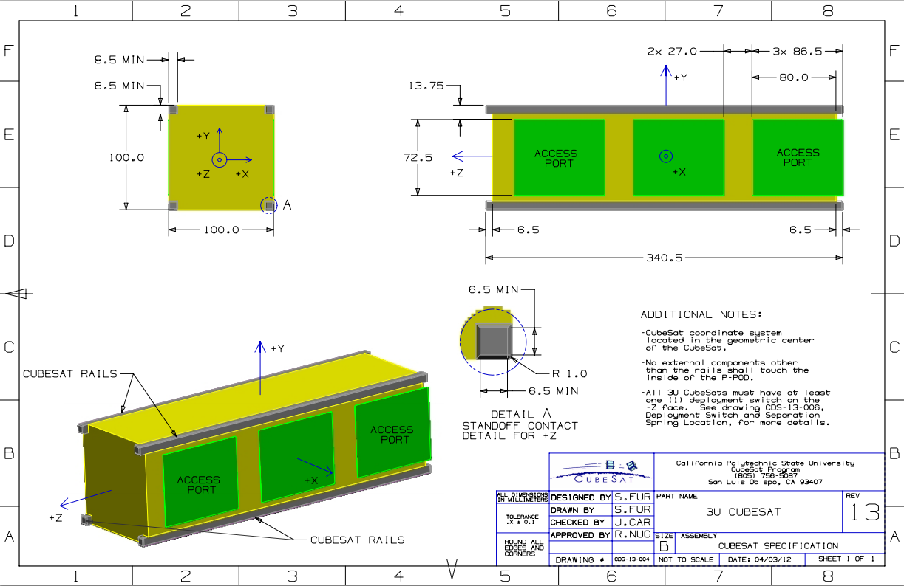

**Figure 1‑1 3U CubeSat Coordinate System Definition**

# Primary-Secondary Spacecraft Interfaces

There exist two main interfaces between the primary and secondary spacecraft:

* Primary-Secondary Separation Mechanism
* Secondary Spacecraft Power Inhibit

The former interface is mainly mechanical in nature, though it will require power to be transferred from the primary to the secondary spacecraft. The latter interface is purely mechanical in nature, taking the form of a simple contact switch. Each interface is described in greater detail in the following sections.

## Primary-Secondary Separation Mechanism

The former interface is mainly mechanical in nature, consisting of two solenoids (each housed within the secondary spacecraft) that latch onto two connection points that extend from the primary, as shown in Figure 2-1. These interface points are located along the vertical center line of the Y-/Y+ faces of the Primary and Secondary Spacecraft respectively, with each point being 5 cm from the Z-/Z+ face of the secondary spacecraft respectively. Four springs will also be used in order to achieve spacecraft separation once the solenoid latches are retracted. The interface for these springs will also be located along the Y-/Y+ faces of the Primary and Secondary Spacecraft respectively, with each spring representing a corner of a 15x5cm rectangle, whose center is located at the center of the Y- face of the secondary spacecraft.

|  |  |
| --- | --- |
|  |  |
| **Figure 2‑1 Example Drawings of Primary-Secondary Mechanical Interface.** The left figure shows a magnified view of the solenoid latch interface, while the right figure shows a magnified view of the separation spring interface. | |

Since the secondary spacecraft is set to be off until separation, it is required that the primary spacecraft transfers power to the secondary spacecraft’s separation mechanism. This will be accomplished through the use of external electrical contact ports, one each for the Primary and Secondary Spacecraft. These ports will be at least 5V, 2.5A rated. A block diagram of this arrangement is shown in Figure 2-3. This diagram specifies that the command for separation originate from a ground station. This command is then received by the Colony-II bus COM system and passed to the Command Data Handling (CDH) system of the Primary Payload. The CDH system then interprets this command and allows for current to flow from the Primary Spacecraft, to the Power Transfer contacts, to the Secondary Spacecraft, and then directly to each of the separation solenoids. Thus, the Primary Payload’s CDH system is responsible for the actual relaying of power to the spacecraft power transfer ports, with the Colony-II bus only being required to receive and relay the actual separation command. This will involve the use of a wire harness to connect the corresponding 5V and GND ports of the CDH system to those of the power transfer port.

Separation will be verified by a contact switch located on the Y+ face of the primary spacecraft. This switch, once de-actuated, will indicate to the Primary Payload’s CDH system that separation has occurred. This information could then be queried from the ground, so that separation can be verified.

SEP Block Diagram.tif

**Figure 2‑2 Separation Subsystem Block Diagram**

## Secondary Spacecraft Power Inhibit

The Secondary Spacecraft Power Inhibit interface is also mainly mechanical in nature, consisting of a simple switch located on the Y- face of the Secondary Spacecraft that will be compressed when the Secondary Spacecraft is conjoined with the primary spacecraft. In this state, the switch would cut off all power between the secondary spacecraft’s batteries and the rest of the secondary spacecraft, ensuring that the secondary spacecraft has enough power to remain active over the course of its 15 day mission. When the secondary spacecraft separates from the primary spacecraft, this switch will actuate to its on state, allowing the secondary spacecraft to be powered on. A block diagram of this arrangement is provided in Figure 2-3.



**Figure 2‑3 Secondary Power Subsystem Block Diagram**

# Primary-Colony-II Bus Interfaces

The main interface between the Primary Payload (PLD) and the Colony-II (COL-II) bus is a D-subminiature DB-25 connector, as shown in Figure 3-1. This interface will be used for passing power from COL-II to the PLD, as well as relaying data collected by the PLD to the communications and attitude determination and control systems (ADC) provided by COL-II and data commands and ADC sensor information from COL-II to the PLD.

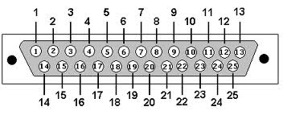

**Figure 3‑1 Example DB-25 Pinout**

**Table 3‑1 Primary-Colony-II Bus Interface Pinout**

| Pin Number | Pin Name | Pin Name (Shorthand) | Signal Origin |
| --- | --- | --- | --- |
|  | Live Image Data/Beacon Transmit | U1TX | PLD |
|  | Payload Data | SDA1 | PLD |
|  | COL-II Data | SDA2 | COL-II |
|  | Radio Request to Send | ~U1RTS | COL-II |
|  | Radio Clear to Send | ~U1CTS | COL-II |
|  | 5V Bus | 5V | COL-II |
|  | 3.3V Bus | 3.3V | COL-II |
|  | Ground | GND | COL-II |
|  | Ground | GND | COL-II |
|  | Unregulated | UNREG | COL-II |
|  | Unassigned |  |  |
|  | Propulsion Firing Circuit Chip Select | ~CS_PRP0 | PLD |
|  | Image Payload Chip Select | ~CS_IMG0 | PLD |
|  | SD Card Input | SDI1 | PLD |
|  | SD Card Output | SD01 | PLD |
|  | SD Chip Select | ~CS_SD | PLD |
|  | SPI Clock | SCL1 | PLD |
|  | I2C Clock | SCL2 | PLD |
|  | 5V Bus | 5V | COL-II |
|  | 3.3V Bus | 3.3V | COL-II |
|  | Ground | GND | COL-II |
|  | Unassigned |  |  |
|  | Unregulated | UNREG | COL-II |
|  | Unassigned |  |  |
|  | Unassigned |  |  |

Table 3-1 shows the pinout of the PLD-COL-II Interface. The table is organized such that each signal is given a name, designation, and origin. The baud rate for any RF data (as indicated by the TX tag) has a maximum value of 10 Mbit/s. All other data signals are nominally set to 9600 bit/s. Table 3-2 lists all of the devices that are to interface with the COL-II bus, while Figure 3-2 illustrates the data flow for all of the devices that are to be used on the Rascal spacecraft.

As can be seen from Figure 3-2, all data that runs between the Colony-II bus and the primary payload must first pass through the Primary Payload’s PIC bus. From there, signals and power are sent out to/received from each of the other devices located within the Primary Payload, including the image payload processor, propulsion system firing circuit, and data storage SD card. Said SD card will be used for storing image data (including full resolution images and their respective relative distance/quaternion data), as to allow for the later downlink and assessment of the Primary Payload’s control algorithms. These control algorithms (which are located on the image processor) will also make use of orientation data outputted by COL-II’s ADC system, thus the necessity of having a data line (SDA2) that originates from the COL-II side of the Primary Spacecraft.

Device Diagram.tif

**Figure 3‑2 Rascal Spacecraft Device Dataflow**

**Table 3‑2 Primary Payload Device List**

| Device | Serial Communication Used |
| --- | --- |
| Image Payload | I2C |
| SD Card | SPI |
| Propulsion Payload | I2C |

# Ground-Spacecraft Interfaces

There exist three interfaces between each spacecraft and the ground:

* Ground-Primary Spacecraft Uplink
* Primary Spacecraft-Ground Downlink
* Ground-Secondary Spacecraft Uplink

These interfaces predominately consist of ground station antennas (located at the Space Systems Research Lab in St. Louis, MO) and spacecraft antennas (either the secondary spacecraft’s UHF patch antenna or the primary spacecraft’s antenna). Each of these interfaces is described in greater detail in the following sections.

Expected ground station pass durations were made with the assumption of one of either three reference missions:

* 300 km Equatorial
* 500 km Equatorial
* 500 km, 45⁰ Inclination



## Ground-Primary Spacecraft Uplink

The primary spacecraft uplink serves to command the primary spacecraft at any point in the mission. The uplink will be act the command link when the primary and secondary spacecraft are conjoined and this is how the command for spacecraft separation will be sent. The uplink data rate must be at least 4000bps and the frequency must be selected from the 430/440 MHz range. The ground station at the SSRL will act as the command station for the primary spacecraft.

The SSRL ground station consists of a 100W

## Primary Spacecraft-Ground Downlink

The primary spacecraft downlink serves to send mission and health data down to the ground. It will beacon health data down at 10 second intervals. The downlink data rate must be at least 100 kbps and the frequency must be selected from the 430/440 MHz range and use GMSK modulation. The ground station at Boeing will act as the primary receiving station with Saint Louis serving as a secondary receiving station.

## Ground-Secondary Spacecraft Uplink

The secondary spacecraft uplink serves to turn off the visual aids for the primary spacecraft it is carrying. If necessary it will also be used to turn them back on. The uplink data rate must be at least 1200 bps, the frequency must be selected from the 430 MHz range, and it must be broadcast using FSK modulation and AX.25 protocol. The ground station at Boeing will act as the primary command station for the secondary spacecraft with Saint Louis serving as a backup station.